MEGHNAD SAHA INSTITUTE OF TECHNOLOGY

*Techno Complex, Madurdaha,Beside NRI Complex, Post-Uchhepota, Kolkata 700 150*

LABORATORY NOTE BOOK

MAKAUT EVEN SEMESTER 2025



[MASTERS OF COMPUTER APPLICATION]

[OPERATING SYSTEM LAB (UNIX) (MCAN-292)]

[RUPAK SARKAR]

ROLL NO: 14271024036 REGN. NO.: 241420510045

STREAM: MCA SEMESTER: II (2ND)

YEAR: 1ST YearSESSION: 2024-2026



MAULANA ABUL KALAM AZAD UNIVERSITY OF TECHNOLOGY



MEGHNAD SAHA INSTITUTE OF TECHNOLOGY

*Techno Complex,. Madurdaha,Beside NRI Complex, Post-Uchhepota, Kolkata 700 150*

“LIST OF ASSIGNMENT/EXPERIMENT SUBMISSION DETAILS”

|  |  |  |  |  |  |
| --- | --- | --- | --- | --- | --- |
| **SL.**  **NO.** | **ASSIGNMENT / EXPERIMENT NAME** | **DATE OF EXPERIMENT** | **DATE OF SUBMISION** | **CHECKED BY** | **REMARKS (ANY DEVIATION REGARDING SUBMISSION DATES, CONTENT, FORMAT, ETC)** |
| 1. | Shell script to find Factorial. | 26/02/2025 | 05/03/2025 |  |  |
| 2. | Shell script to find Even or Odd number. | 26/02/2025 | 05/03/2025 |  |  |
| 3. | Shell script to find Even or Odd number from 1 to 10. | 26/02/2025 | 05/03/2025 |  |  |
| 4. | Shell script to implement Switch Case. | 26/02/2025 | 05/03/2025 |  |  |
| 5. | Shell script to implement a Calculator. | 26/02/2025 | 05/03/2025 |  |  |
|  |  |  |  |  |  |
|  |  |  |  |  |  |
|  |  |  |  |  |  |
|  |  |  |  |  |  |
|  |  |  |  |  |  |

|  |
| --- |
| OBSERVATIONS / COMMENTS ON THE OVERALL PERFORMANCE: |

Signature in full with date Signature in full with date

**Faculty / Technical Assistant Lab Examiner**

**Q.1. Write a shell script to find factorial of a number.**

Ans:

#!/bin/bash

echo -n "Enter the number to check: "

read num

fact=1

i=$num

while [ $i -gt 1 ]

do

fact=$((fact * i))

i=$((i - 1))

done

echo -e "\nFactorial of $num is $fact"

Output:

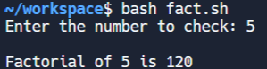

**Q.2. Write a shell program to find whether a number is even or odd.**

Ans:

#!/bin/bash

echo -n "Enter the number to check: "

read num

if [ $((num % 2)) -eq 0 ]

then

echo "$num is even"

else

echo "$num is odd"

fi

Output:

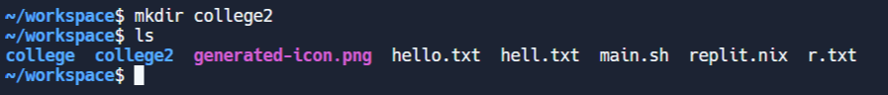

**Q.3. Write a shell program to print even and odd numbers from 1 to 10.**

Ans:

#!/bin/bash

echo "Even numbers between 1 and 10: "

for num in {1..10}

do

if [ $((num % 2)) -eq 0 ]

then

echo -n "$num "

fi

done

echo -e "\nOdd numbers between 1 and 10: "

for num in {1..10}

do

if [ $((num % 2)) -ne 0 ]

then

echo -n "$num "

fi

done

Output:

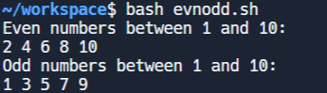

**Q.4. Write a shell script to implement various commands with switch case.**

Ans:

#!/bin/bash

echo -e "Commands: "

echo -e " i) List of Files\n ii) No of processes running\n iii) Date\n iv) No of Users\n v) Exit\n"

echo -n "Enter any option: "

read n

case $n in

i) ls -l ;;

ii) ps -f ;;

iii) date ;;

iv) who ;;

v) exit ;;

*) echo "Invalid option. Please try again." ;;

esac

Output:

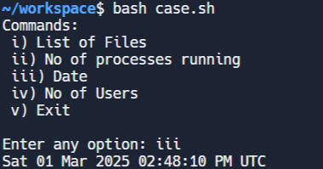

**Q.5. Write a shell script to implement a calculator.**

Ans:

#!/bin/bash

echo -n -e "\nEnter two numbers: "

read a b

echo -e "\n"

echo "Options:"

echo "1) Addition"

echo "2) Subtraction"

echo "3) Multiplication"

echo "4) Division"

echo -n -e "\nEnter the option: "

read option

echo -e "\n"

case $option in

1) echo "Result: $(expr $a + $b)";;

2) echo "Result: $(expr $a - $b)";;

3) echo "Result: $(expr $a \* $b)";;

4) echo "Result: $(expr $a / $b)";;

*) echo "Invalid option!";;

esac

Output:

